OPS 102 – Lab 10 (%3 of total mark)

Student Name: Yicheng Wang

Student ID: 150868206

* Review the following questions and provide 1 line answers.
* Use color red when providing answers.
* Do not copy and paste answers
* Provide screenshots for the questions below.

Your input file:

*This is a sample text with various elements like cat, hat, and bat. Phone numbers such as 123-4567 and 987-6543 can be found here. You might also find apple and banana in this text. The dates could be in the format 12/31/2023 or 06-15-2022. Please validate email addresses like example@email.com or invalid_email.666. Social security numbers (SSNs) like 123-45-6789 and 666-12-3456 may appear. Visit https://www.example.com for more information.*

1. Create a regular expression pattern to match the word "cat" in the provided text.

egrep '\<cat\>' sample.txt

2. Develop a regular expression pattern that matches any three-letter word ending with "at" in the provided text.

egrep '\<[a-zA-Z]at\>' sample.txt

3. Write a regex pattern that matches phone numbers in the format XXX-XXXX in the provided text, where X represents a digit.

egrep '\<[0-9]{3}-[0-9]{4}\>' sample.txt

4. Create a regex pattern that matches either "apple" or "banana" in the provided text.

egrep '(\<apple\>)|(\<banana\>)' sample.txt

5. Develop a regex pattern to match dates in the format MM/DD/YYYY or MM-DD-YYYY in the provided text, where MM represents the month, DD the day, and YYYY the year.

egrep '\b(0[1-9]|1[0-2])[/-](0[1-9]|[12][0-9]|3[01])[/-][0-9]{4}\b' sample.txt

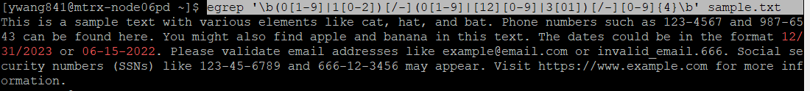

6. Write a regex pattern that validates email addresses in the provided text. Test it with the input text, both for valid and invalid email addresses *like example@email.com or invalid_email.666.*

egrep '\b[A-Za-z0-9._%+-]+@[A-Za-z0-9.-]+\.[A-Za-z]{2,}\b' sample.txt

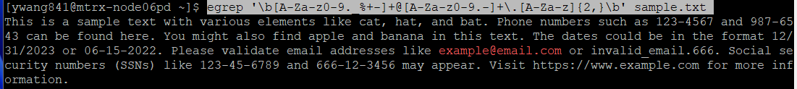

7. Create a regex pattern that matches social security numbers (SSNs) in the format XXX-XX-XXXX in the provided text, where X represents a digit.

egrep '\b[0-9]{3}-[0-9]{2}-[0-9]{4}\b' sample.txt

8. Write a regex pattern that identifies and captures URLs in the provided text:

egrep 'https?://[a-zA-Z0-9.-]+\.[a-zA-Z]{2,}(/\S*)?' sample.txt

